Name: ______________________________ Test: __________________________ Pd. _____

AP History Intervention Activity
Come in during tutoring hours on Thursdays (both lunches) or after school by appointment

Step 1: Grab your test and complete the boxes below for up to 8 Questions Missed. For the last box, use the following:
- Misread the Question/Answers
- Mixed Up Information
- Didn’t Know the Answer
- Misunderstood the Question

Question # | Historical Thinking Skill(s) Covered (Based on what you think) | Course Theme(s) Covered  (Based on what you think) | Why did you get it incorrect? (Letter Above)

Step 2: Based off the chart above, answer the following questions about your test.
- I am missing questions that are based on (Circle One):
  - Historical Thinking Skills (Stimulus Based items, Interpretation, Argumentation questions)
  - Themes/Content (factual knowledge from the unit)
  - Both A and B

- Why did you get the majority of the questions that you missed wrong?

_____________________________________________________________________________

- What are you going to do before the next test to change this? Think about the following:
  - Misread the Question/Answers = Might need to slow down/go back over questions during the test
  - Mixed Up Information = Might need to change how I studied
  - Didn’t Know the Answer = Might need to change how I studied
  - Misunderstood the Question = Might need to ask the teacher to clarify during the test

______________________________________________________________________________
Step 3: If you think you’re missing questions because you’re struggling with Historical Thinking Skills, choose a Historical Thinking Skill practice sheet based on the ones you were missing in the exam. If you think you’re missing questions because you’re struggling with the content, then grab the “Historical Themes” Chart. You have until the end of the new unit to complete one of these tasks for Credit Recovery ON YOUR OWN TIME.

Historical Thinking Skills:
- Historical Causation: Identifying, analyzing and evaluating the relationships and interactions of multiple causes and effects, distinguishing between long-term and short-term causes and effects.
- Patterns of Continuity and Change: Recognizing, analyzing and evaluating patterns of continuity, that which remains the same over long periods of time, as well as changes, short-term and long-term, over time.
- Periodization: Dividing history into periods by identifying turning points and recognizing that those points may be different for each region and group, depending on what is considered most significant to that place or group.
- Comparison: Comparing and contrasting, showing similarities and/or differences in historical developments and processes across place, time, and/or societies.
- Contextualization: Connecting historical events and processes to specific circumstances of time and place and to broader regional, national, or global processes.
- Historical Argumentation: Constructing an argument to address a question about the past through the development of a clear thesis and supporting the argument with relevant historical evidence.
- Appropriate Use of Relevant Historical Evidence: Describing/analyzing evidence from diverse sources, extracting useful information, making supportable claims, and drawing appropriate conclusions from historical evidence.
- Interpretation: Analyzing diverse historical interpretations and evaluating how historians’ perspectives influence their interpretations and how models of historical interpretation change over time.
- Synthesis: Developing meaningful and persuasive new understandings of the past by applying all of the other historical thinking skills, drawing appropriately on ideas and methods from different fields of inquiry or disciplines, and/or fusing disparate, relevant, and sometimes contradictory evidence from primary sources and
secondary works.

AP World Themes (SPICE):
- Interaction Between Humans and the Environment [ENV]
  - Demography and disease
  - Migration
  - Patterns of settlement
  - Technology
- Development and Interaction of Cultures [CUL]
  - Religions, Belief systems, philosophies, ideologies
  - Science and technology
  - The arts and architecture
- State-building, Expansion, and Conflict [SB]
  - Political structures and forms of governance, Empires
  - Nations and nationalism
  - Revolts and revolutions
  - Regional, transregional and global structures and organizations
- Creation, Expansion, and Interaction of Economic Systems [ECON]
  - Agricultural and pastoral production
  - Trade and commerce
  - Labor systems
  - Industrialization
  - Capitalism and socialism
- Development and Transformation of Social Structures [SOC]
  - Gender roles and relations
  - Family and kinship
  - Racial and ethnic constructions
  - Social and economic classes

Step 4: Once you complete the appropriate sheet, bring it to class and you will have the opportunity to retake the test for full credit. You have until the end of the new unit (next unit test) to retake tests.

Name: ___________________________ Test/Unit: _________________________ Pd: _____

HTS 1: Historical Causation Practice Activity

Identifying, analyzing and evaluating the relationships and interactions of multiple causes and effects, distinguishing between long-term and short-term causes and effects.

Historical Event in the Unit: __________________________________________________________________________

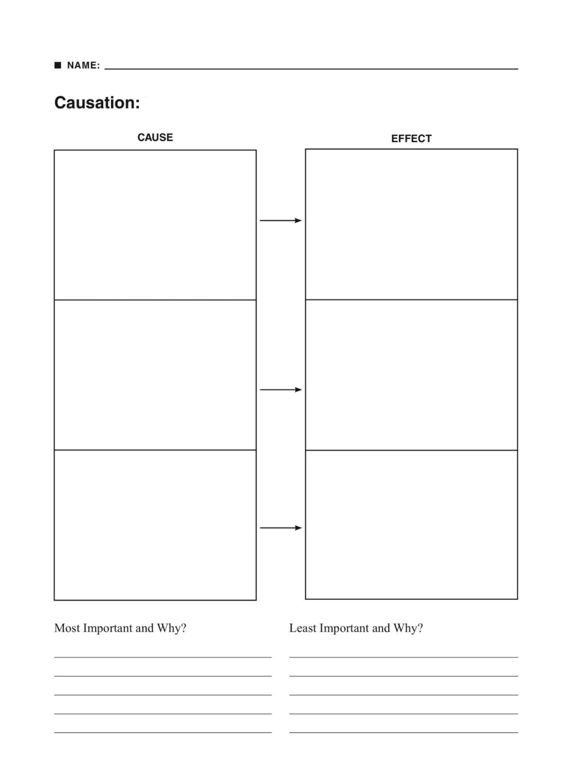
Do all of the items listed above exhibit a true cause and effect relationship, or are there some events that are more the result of correlation (related, but not truly cause/effect) or perhaps coincidence? Explain your answer below.

_____________________________________________________________________________________

_____________________________________________________________________________________

_____________________________________________________________________________________

Name: ___________________________ Test/Unit: ______________________ Pd: ______

HTS 2: Patterns of Continuity and Change Practice Activity

Recognizing, analyzing and evaluating patterns of continuity, that which remains the same over long periods of time, as well as changes, short-term and long-term, over time.

Topic/Concept in the Unit: __________________________________________________________________

What period are we in? What timeframe is that period?: ________________________________________

Choose one Region to Discuss: __________________________________________________________________

At least 4 pieces of information for topic from the BEGINNING of the given timeframe | At least 4 pieces of information for topic from the END of the given timeframe

- Draw a line between the items in the first and second parts of the chart that are the same or similar
  - WHY did those items remain the same or similar over time?

_____________________________________________________________________________________

_____________________________________________________________________________________

_____________________________________________________________________________________

_____________________________________________________________________________________

- Circle the items in the second column that ARE NOT in the first column. Those are your changes.
Check: Do you have at least one line, and at least one circle? If not, you need to go back and add items above!
  - WHY did those items change?

_____________________________________________________________________________________

_____________________________________________________________________________________

_____________________________________________________________________________________

_____________________________________________________________________________________

Name: ____________________________ Test/Unit: _______________________ Pd: ____

HTS 3: Periodization Practice Activity

Dividing history into periods by identifying turning points and recognizing that those points may be different for each region and group, depending on what is considered most significant to that place or group.

Time Period of this Unit (dates and title of the official “Period”): _____________________________________________

Regions addressed in this Unit: ________________________________________________________________________

4 Characteristics of This Time Period That Support It’s Title for the Regions of the unit | 4 Characteristics of this Time Period that Contradict It’s Title

Based off your list above, give this time period an alternate title and explain your choice below.

Alternate Title: ____________________________________________________________________________________

Explanation: __________________________________________________________________________________

_____________________________________________________________________________________________

_____________________________________________________________________________________________

_____________________________________________________________________________________________

_____________________________________________________________________________________________

Name: ____________________________ Test/Unit: _______________________ Pd: ____

HTS 4: Comparison Practice Activity

Comparing and contrasting, showing similarities and/or differences in historical developments and processes across place, time, and/or societies.

What period are we in? What timeframe is that period?: ________________________________________

Choose TWO regions/concepts to compare and fill in the Venn diagram (including the middle).
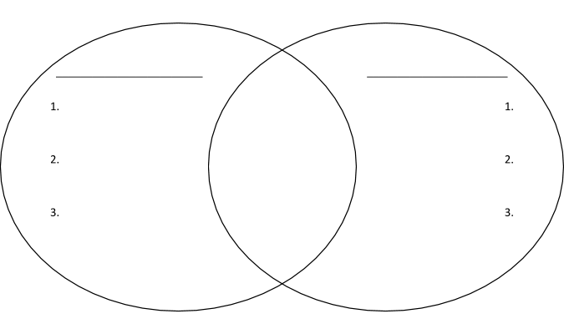

Check: Did you have at least one similarity, and at least one difference?
Choose one similarity to analyze. What was similar, and why did that similarity occur?

_____________________________________________________________________________________________

_____________________________________________________________________________________________

_____________________________________________________________________________________________

Choose one difference to analyze. What was different, and why did that difference occur?

_____________________________________________________________________________________________

_____________________________________________________________________________________________

_____________________________________________________________________________________________

Name: ____________________________ Test/Unit: _______________________ Pd: ____

HTS 5: Contextualization Practice Activity

Connecting historical events and processes to specific circumstances of time and place and to broader regional, national, or global processes.

Time Period of this Unit (dates and title of the official “Period”): _____________________________________________

Regions/Concepts addressed in this Unit: _______________________________________________________________

Choose three historical events from this unit and “Contextualize” it by connecting it to the bigger picture.

Historical Event: | Connection to what is happening…  Regionally/Within Country:  Globally:  Another Theme:
Historical Event: | Connection to what is happening…  Regionally/Within Country:  Globally:  Another Theme:
Historical Event: | Connection to what is happening…  Regionally/Within Country:  Globally:  Another Theme:

Now, choose one of the above, and write a “contextualization sentence” that places the issue into the broader picture:
_____________________________________________________________________________________________

_____________________________________________________________________________________________

_____________________________________________________________________________________________

_____________________________________________________________________________________________

Name: ____________________________ Test/Unit: _______________________ Pd: ____

HTS 6: Historical Argumentation Practice Activity

Constructing an argument to address a question about the past through the development of a clear thesis and supporting the argument with relevant historical evidence.

Time Period of this Unit (dates and title of the official “Period”): _____________________________________________

Regions/Concepts addressed in this Unit: _______________________________________________________________

Choose TWO primary sources from this unit. Get them from your book or the primary source material we utilized during this unit.

Source 1: _______________________________________________________________

Source 2: _______________________________________________________________

Identify a claim about history made by either your teacher or your book that relates to those two documents:

_____________________________________________________________________________________________

_____________________________________________________________________________________________

_____________________________________________________________________________________________

Using the two primary sources and your knowledge from this unit, analyze how the documents support or do not support the claim made by your book or the lectures during this unit.

_____________________________________________________________________________________________

_____________________________________________________________________________________________

_____________________________________________________________________________________________

_____________________________________________________________________________________________

_____________________________________________________________________________________________

_____________________________________________________________________________________________

_____________________________________________________________________________________________

_____________________________________________________________________________________________

_____________________________________________________________________________________________

_____________________________________________________________________________________________

_____________________________________________________________________________________________

_____________________________________________________________________________________________

Name: ____________________________ Test/Unit: _______________________ Pd: ____

HTS 7: Historical Evidence Practice Activity

Describing/analyzing evidence from diverse sources, extracting useful information, making supportable claims, and drawing appropriate conclusions from historical evidence.

Time Period of this Unit (dates and title of the official “Period”): _____________________________________________

Regions/Concepts addressed in this Unit: ________________________________________________________________

Choose one primary source from your book, this unit, or the test that you struggled to analyze, or analyzed incorrectly. Then complete the following chart.
Title and Author of the Source: | Title:  Author:
What is the MOST important take away from the source for this class?

“Source” the Document with one of these:
POV, Purpose, Audience, Historical Context

Connect the document to the reading, class lectures etc.
How is this document relevant to the unit? How is this document relevant to the course as a whole?

What is a “conclusion” you can draw about the time period or region, or both, from this source?

Name: ____________________________ Test/Unit: _______________________ Pd: ____

HTS 8: Interpretation Practice Activity

Analyzing diverse historical interpretations and evaluating how historians’ perspectives influence their interpretations and how models of historical interpretation change over time.

Time Period of this Unit (dates and title of the official “Period”): _____________________________________________

Regions/Concepts addressed in this Unit: ________________________________________________________________

Choose one primary source from your book, this unit, or the test that you struggled to analyze, or analyzed incorrectly. Then complete the following chart.
Title and Author of the Source:

What is this document about? (Summary)

FULLY “Source” the Document! | POV – What is this person’s… (If you can’t tell, just say “not included”)  NATION -  RACE -  CLASS -  GENDER -  OCCUPATION -  RELIGION –
 | Purpose of the Document:
 | Intended Audience of the Document:
 | Historical Context:

Now, choose one of the above sourcing elements, and write a sentence that sources the document:

_____________________________________________________________________________________
_____________________________________________________________________________________

_____________________________________________________________________________________

Name: ____________________________ Test/Unit: _______________________ Pd: ____

HTS 9: Synthesis Practice Activity

Developing meaningful and persuasive new understandings of the past by applying all of the other historical thinking skills, drawing appropriately on ideas and methods from different fields of inquiry or disciplines, and/or fusing disparate, relevant, and sometimes contradictory evidence from primary sources and secondary works.

You’ll choose an historical event from the time frame and region/concept of this test, and follow the graphic organizer.
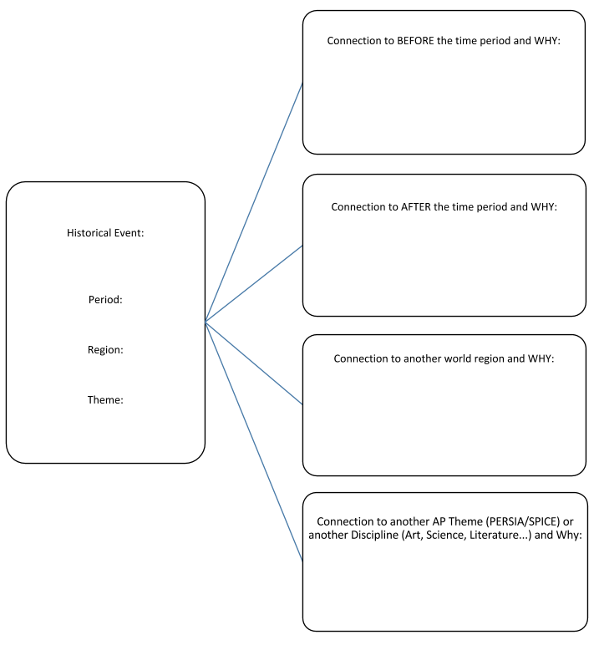

Name: ____________________________ Test/Unit: _______________________ Pd: ____

Historical Themes Practice: SPICE Chart
Fill in the boxes below with Cultural, Authoritative, Societal, Trade, and Environmental Events of the chapter/unit. These follow our historical themes!
Time Span/Region: ____________________________________________________
S
(Theme 5: Development & Transformation of Social Structures)

P
(Theme 3:
State Building, Expansion, Conflict)
I
(Theme 1: Interaction Between Humans and the Environment)
C
(Theme 2: Development and interaction of cultures)
E
(Theme 4: Creation, Expansion, & Interaction of Economic Systems)

