Civilization Autopsy

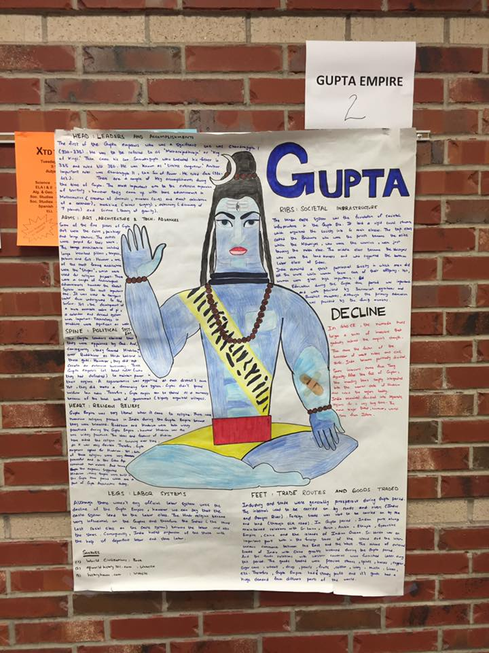 | 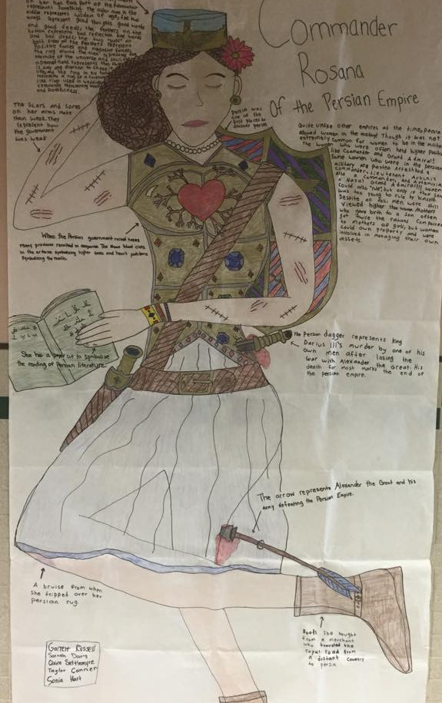 | 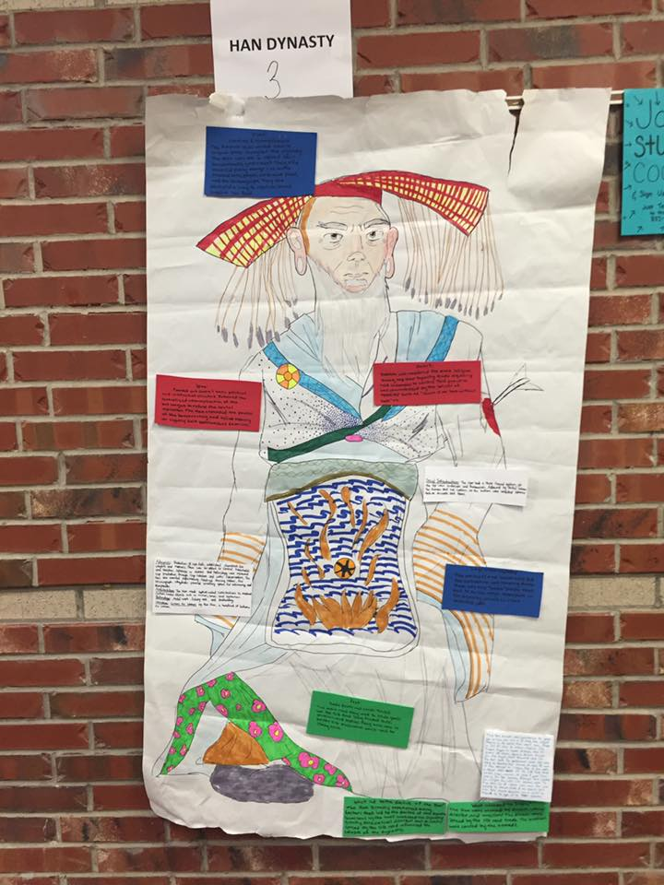

Directions: You and your group will be looking into the success and eventual downfall of a classical empire. You will be depicting this through an autopsy report.

You will need notes on each one of the empires, but will only be assigned a poster for one of the following:

Empires:
- Persia (Achaemenid, Parthian and Sassanid)  - China (Han)  - India (Guptan) | - Mediterranean (Rome)  - Greece city-states (Athens / Sparta)

Part One: Empire Obituary Give me a clear picture of what this empire was like during healthier times, broken down into the following categories:
- Head: Significant Leaders & Accomplishments  - Hands: Art, incl. Literature, Architecture & Tech. Advances  - Legs: Labor Systems  - Spine: Political Structure | - Ribs: Social Structure  - Heart: Religious Beliefs  - Feet: Trade routes and goods traded

Part Two: Autopsy:
- What led to the decline of this empire?
- What weakened it? What led to their demise?
- Be creative in your delivery.

Other Information:
- You need at least two sources of information.
  - One can be your textbook.
  - Cite in MLA Format
- Write your empire information in one color.
- Write your autopsy info in a different color.
- Here’s a general idea of what I’m looking for:

Rubric:
 | Exemplary (100%-90%) | Proficient  (89%-80%) | Partially Proficient (79%-70%) | Unsatisfactory (69%-0%)
Content  ____/50 | - Content is accurate  - Content is detailed  - Content is exemplary  - Content is presented according to directions | - Content is accurate  - Content is adequate  - Content is comprehensive  - Content is presented according to directions | - Content is accurate  - Content is too basic  - Content is is missing a few details  - Content is mostly presented according to directions | - Content is inaccurate  - Content lacks necessary detail  - Content is missing  - Content isn’t presented as asked
Organization  ____/25 | - Info is where it’s supposed to be  - Poster is neat and easy to read  - Name/class period are included  - Sources are cited | - Info is where it’s supposed to be  - Poster is adequately legible  - Name/class period are included  - Sources are cited | - Info is on the poster  - Poster is mostly legible  - Name/class period are included  - Sources are cited, incorrectly | - Info is missing  - Poster isn’t legible  - Name and/or class period missing  - Sources not cited
Creativity/Aesthetics  _____/25 | - High level of effort apparent  - Poster is colorful and creative  - Organized in a pleasing manner  - Content is easy to read and flows | - Effort is apparent  - Poster is colorful and gets the point across  - Poster is organized  - Content is easy to read | - Effort is so-so  - Poster lacks color or creativity  - Poster isn’t organized very well  - Content is illegible or rushed | - Effort is embarrassing  - Poster has no color or creativity  - Poster has no obvious organization  - Content is terrible

