Persians and Gender
An Analysis of Art

Document A

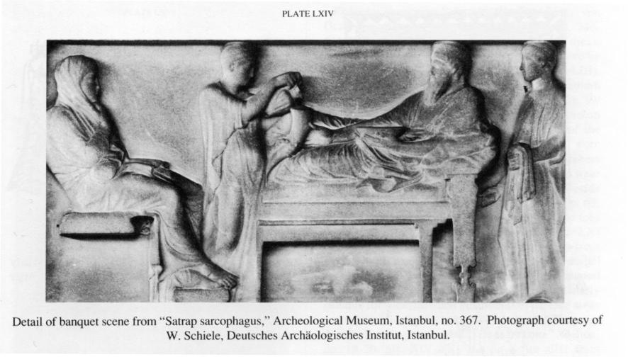
Figure 1: Satrap Sarcarphagus c. 550 - 500 BCE.
Complete a SOAPSTONE analysis for the image.

S
O
A
P
S
Tone

Based on the analysis, answer the following questions. Be sure to include evidence from the image to support your answers.

- The first is an image of a banquet. Who do you think is seated around the table? What is their gender?

- What makes you believe this?

Document B

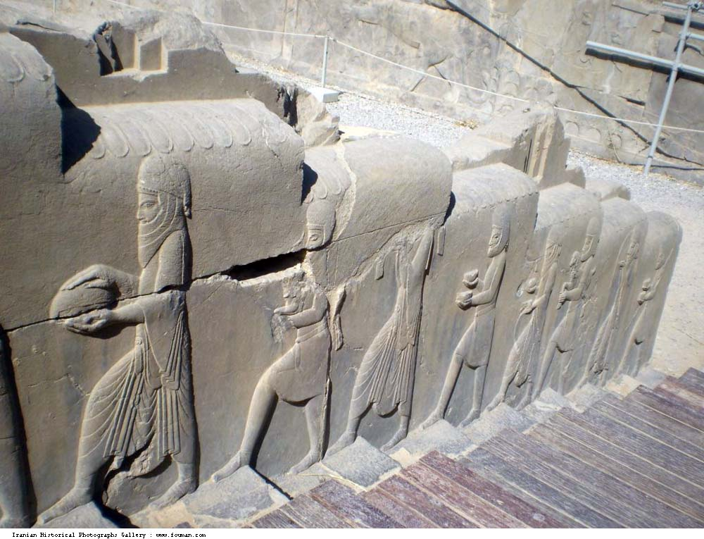
Figure 2: Persepolis, representatives of 28 nations waiting to present gifts to Shahansha.

Complete a SOAPSTONE analysis for the image.

S
O
A
P
S
Tone

Based on the analysis, answer the following questions. Be sure to include evidence from the image to support your answers.

- What is their gender of people bearing gift? How do you know?

- What does this imply about the gender politics and government of Persia and surrounding nations?

Document C

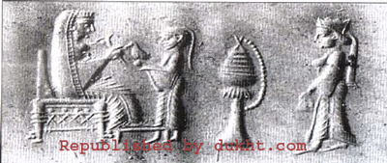
The final image depicts an Achaemenid king on his throne with a queen on the far right. Another women is giving a bird to the king.

Complete a SOAPSTONE analysis for the image.

S
O
A
P
S
Tone

Based on the analysis, answer the following questions. Be sure to include evidence from the image to support your answers.

- How does the dress of the queen compare with the king? Her position?

- What does this image tell us about the role of women in Persian government?

