- Compare and contrast the effects of the global flow of silver from the mid-sixteenth century to the early eighteenth century between Spain and China.

Document 1
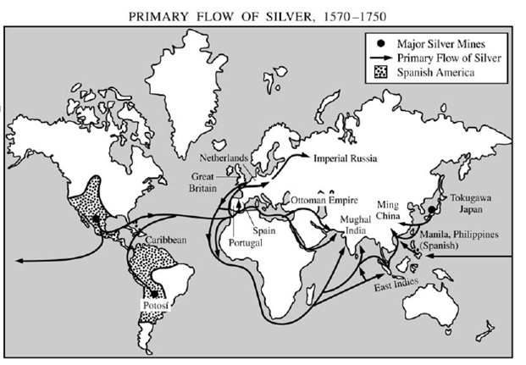

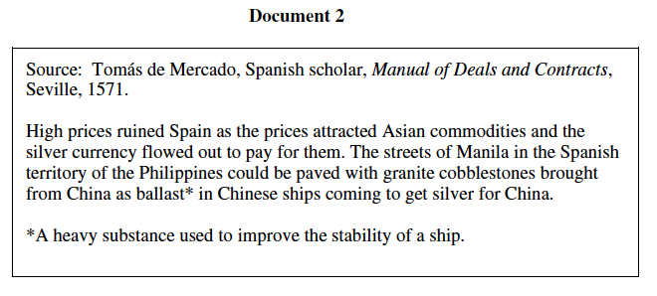
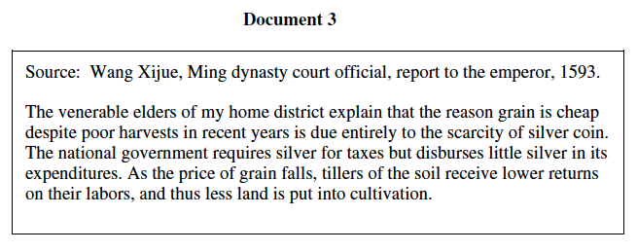

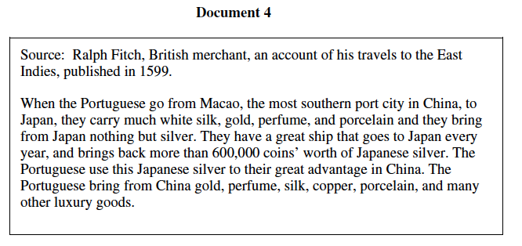
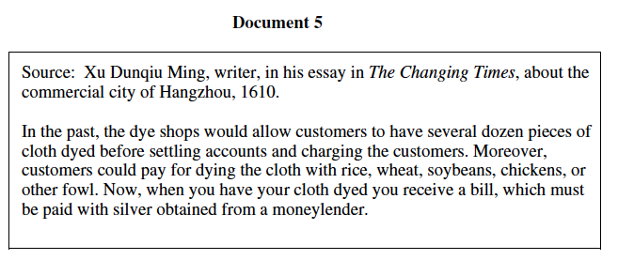

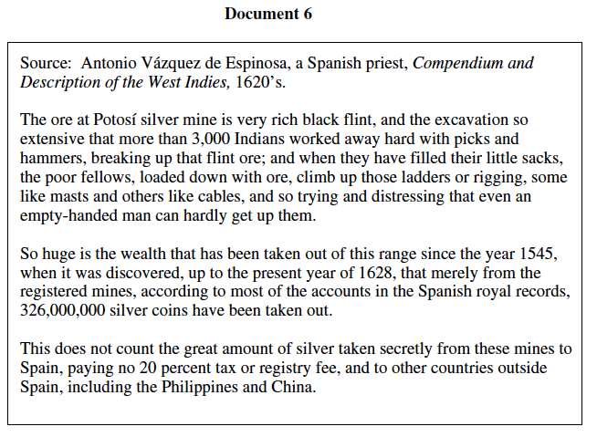

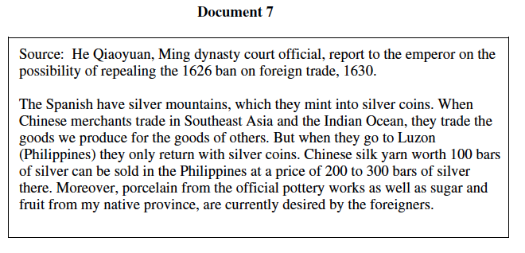

- “Big C” Context?
  - Mercantilism; colonies.
  - Age of Exploration.
- Synthesis?
  - Mansa Musa’s (of Mali) pilgrimage to Mecca (14th century); caused massive inflation through his use of gold.
- Evidence Beyond the Docs?
  - Breakdown of the Confucian values/ traditional Chinese culture.
  - Columbian Exchange.
  - Mercantilist companies.

Learning Objectives (from CED):
- 3.1.1
  - ECON-10 Analyze the roles of pastoralists, traders, and travelers in the diffusion of crops, animals, commodities, and technologies.
  - ECON- 12 Evaluate how and to what extent networks of exchange have expanded, contracted, or changed over time.
- 5.1.11
  - ECON- 3 Assess the economic strategies of different types of states and empires.

