WHAP Writing the Long Essay Question (LEQ)

Step One: Figure out what the question is asking. Which HTS is being evaluated ? Circle action words, underline most important tasks or things to include. What type of Thinking Map will you use? Rewrite in your own words.

Step Two: Choose the appropriate Thinking Map and fill out. Include all you can remember about the subject.

RED Step Three: Make a list of concrete details (facts from the Thinking Map). Determine ways to categorize the concrete details into global reasons. Try to determine three global reasons from the concrete details you have. Label each CD with one of the global reasons.

GREEN Step Four: For each global reason, write a commentary sentence that explains the connection between the global reason, the concrete details and your thesis. This must be in your own words and explain HOW the concrete details (facts) prove your thesis or argument.

BLUE Step Five: Write the thesis, being sure to cite your claim and give the global reasons you determined to supporting the claim.

BLACK Step Six: Determine the Synthesis. How can you connect this to a different region? Is it similar to something else that happened in a different region or time period?

Step Seven: Complete the FLEE map to plan your writing.

Step Eight: Write the essay.

Step Nine: Read aloud. Does it make sense? If not, change it. Check the rubric. Did you meet all points? If not, change it.

Cause and Effect Prompt:
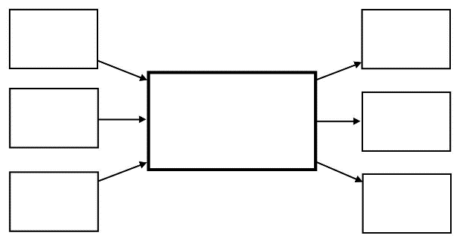

Compare and Contrast Prompt:

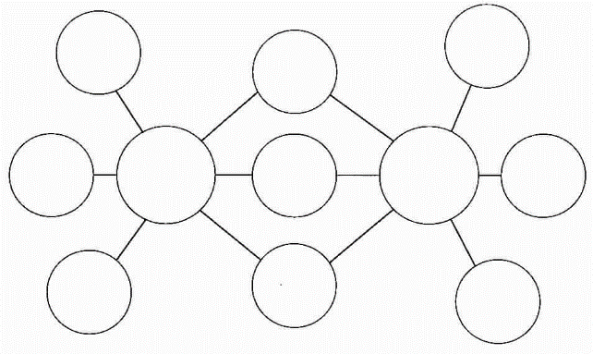

Change and Continuity Over Time Prompt:
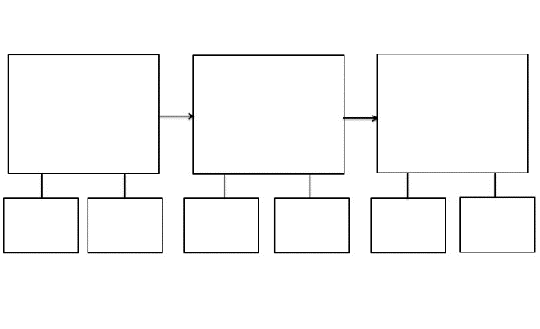

Periodization Prompt:

Event / Time Period

Conditions Before Conditions After

______________ ______________
______________ ______________
______________ ______________

